**Freedom of Information Act / Environmental Information Regulations Request**

Reference: ECC15386608 09 23  
Response: 14 September 2023

I can confirm that Essex County Council does hold some of this information, and where we are able to release this, our response is listed below.

**Question 1. Please could you forward this to your Flood Risk Management Team. I am currently writing a Flood Risk Assessment for 365 Little Wakering Road, Little Wakering, SS3 0LB on behalf of Delta Simons Environmental Consultants. The site is shown to be located in flood zone 3, and partially at risk from surface water flooding. I would be grateful if you could please provide the following:**

**• any records of historical flooding in or around the area;**

**• any information related to surface water flooding in or around the area;**

**• any information relating to drainage issues or sewer flooding in the area;**

**• any details of flood defences in the area.**

**Additionally, if you hold any information on the Hold the Line Policy in place for the site as part of the 2010 Essex and South Suffolk Shoreline Management Plan (such as planned upgrades/raising of any tidal flood defences in the area) this would be greatly appreciated.**

There are no records of historical flooding in or around the area. The property itself has a low risk of surface water flooding, as per screen shot below, however the street is on a flood path and has a high risk of flooding, so there could be occasional flooding to the front garden/driveway. This information is also accessible online at: [Check if you’re at risk of flooding (essex.gov.uk)](https://flood.essex.gov.uk/what-to-do-about-flooding/check-if-you-re-at-risk-of-flooding/)

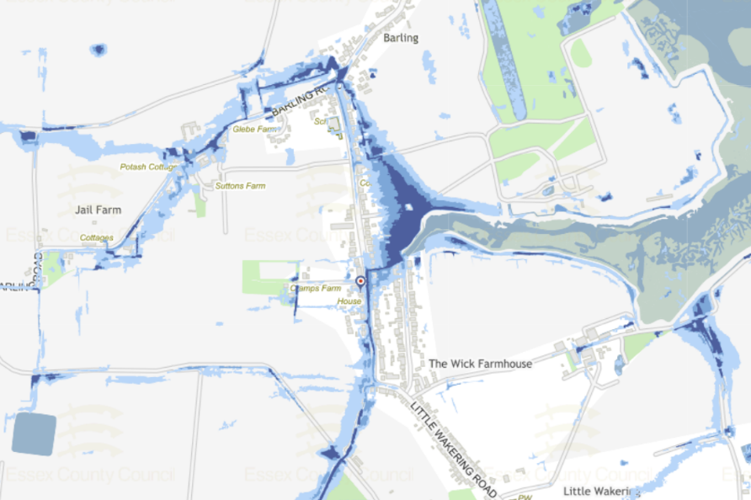

Sewer flooding issues and records will be held by the respective water company.

There are no recorded flood defences in the area by Essex County Council, but we do not hold records of all flood defences. Barlinghall Creek which ends at Little Wakering Road, is categorized as a main river and so managed by The Environment Agency (EA); therefore, the EA may have some form of flood defence around the creek.

We don’t hold any information on the Hold the Line Policy. The Environment Agency are the Lead Partner for the Essex and South Suffolk Shoreline Management Plan and also have a 'strategic overview' role whereby they exercise strategic leadership for all sources of flooding and coastal change.

**Your Right to Know**

Democracy and Transparency

Essex County Council

Telephone: 033301 38989

Email: [YourRight.ToKnow@essex.gov.uk](mailto:YourRight.ToKnow@essex.gov.uk) | [www.essex.gov.uk](http://www.essex.gov.uk)