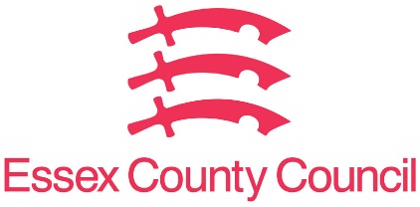

**Freedom of Information Act / Environmental Information Regulations Request**

Reference: ECC18504428 05 25  
Response: 04 June 2025

I can confirm that Essex County Council does not hold this information.

**I am writing to request information under the Freedom of Information Act 2000 regarding a traffic survey on the B1013 Main Rd Hawkwell reportedly conducted by or on behalf of a developer in relation to [insert development name or planning application reference, if known], within [insert location, e.g. Rochford district].**

**Specifically, I would like to request the following:**

**1. Survey commissioning details**

**• Was Essex County Council involved in commissioning or approving the scope, timing, or methodology of the traffic survey in question?**

**• Please provide the name of the developer or third party responsible for commissioning and/or carrying out the survey.**

**2. Survey timing**

**• On what dates and times was the traffic survey conducted?**

**• Were any of these dates during a weekend, public holiday, or school holiday period? If so, please identify the relevant dates.**

**3. Survey review & validation**

**• Has Essex County Council reviewed or validated the findings of the traffic survey? If so, please provide a copy of any reviews, comments, or assessments made by council officers or independent consultants.**

**• Is Essex County Council satisfied that the timing of the survey provides a representative picture of typical traffic conditions?**

**4. Traffic survey data**

**• Please provide a copy of the full traffic survey report(s) submitted to the council, including raw data if available.**

**• Please also provide all and any correspondence between the developer (or their agent) and Essex County Council regarding the traffic survey. Copies of all recorded communications (including but not limited to emails, instant messages, WhatsApp messages, other messaging platforms, attachments, and associated documents) exchanged between:**

**I challenge the validity of the survey data, given its timing during a bank holiday weekend, also including that there is currently cadent gas road work also being conducted along Main Road Hawkwell/Hockley.**

**The lack of transparency by councils informing residents prior to the survey being conducted.**

Essex County Council has no information regarding count data which may have recently been undertaken by developers in relation to future development proposal in Rochford district. The survey was not conducted by Essex Highways and we’ve received no third-party notification of intent.

**Your Right to Know**

Democracy and Transparency

Essex County Council

Telephone: 033301 38989

Email: [YourRight.ToKnow@essex.gov.uk](mailto:YourRight.ToKnow@essex.gov.uk) | [www.essex.gov.uk](http://www.essex.gov.uk)