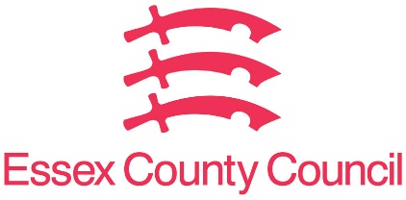

**Freedom of Information Act / Environmental Information Regulations Request**

Reference: ECC18818731 07 25  
Response: 31 July 2025

**I would like to request the following information regarding chewing gum removal for the financial years 2019/20 to 2023/24 inclusive:**

**1. Chewing gum removal costs**

**A. The total cost incurred by the council for chewing gum removal in each of these years.**

**2. Area covered**

**A. If recorded, the approximate area cleaned (in square metres) for each year.**

**3. External funding**

**A. Has the council received any external funding (e.g. from DEFRA or Keep Britain tidy) specifically for chewing gum removal during this period?**

**B. If yes, please provide the amount received and year awarded.**

**If cost data is not held separately:**

**If your authority does not hold chewing gum removal costs separately from general street cleansing budgets, please confirm:**

**1. Whether chewing gum removal is carried out at all, and**

**2. If so, whether it is delivered as part of broader cleansing operations.**

**Format & scope**

**Please provide the data in spreadsheet or tabular format if possible.**

I can confirm that Essex County Council does not hold this information. Your request should be directed to City, District and Borough Councils who may be able to provide you with the information. Please see our webpages which should help you further.

[Request information about the Council | Essex County Council](https://www.essex.gov.uk/running-council/request-information-about-council)

[Contact your local council | Essex County Council](https://www.essex.gov.uk/contact-your-local-council)

**Your Right to Know**

Democracy and Transparency

Essex County Council

Telephone: 033301 38989

Email: [YourRight.ToKnow@essex.gov.uk](mailto:YourRight.ToKnow@essex.gov.uk) | [www.essex.gov.uk](http://www.essex.gov.uk)