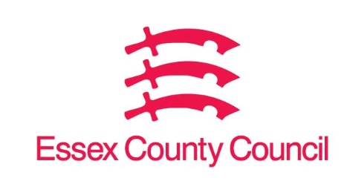

**Freedom of Information Act / Environmental Information Regulations Request**

Reference: ECC17043322 07 24  
Response: 25 July 2024

**Question 1 -** **I would like to know the number of applications made by mainstream schools/academies to open Special Educational Needs (SEN) units in the academic year to date, for 2023-2024 academic year, and for 2022-2023 academic year and how many were approved.**

**Question 2 - I would also like a breakdown of the region the school applying was based in and the phase of the school. If the cost of the breakdown exceeds the threshold, please just provide the other information requested.**

I can confirm that Essex County Council does not hold this information, you need to approach the DfE as Applications go via the significant change process to the DfE.

[Contact the Department for Education (DfE) - GOV.UK (www.gov.uk)](https://www.gov.uk/contact-dfe)

**Your Right to Know**

Democracy and Transparency

Essex County Council

Telephone: 033301 38989

Email: [YourRight.ToKnow@essex.gov.uk](mailto:YourRight.ToKnow@essex.gov.uk) | [www.essex.gov.uk](http://www.essex.gov.uk)