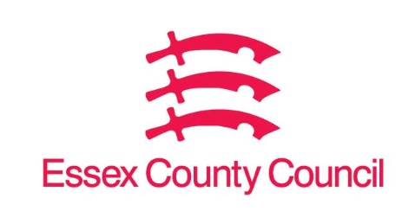

**Freedom of Information Act Request**

Reference: ECC18057727 02 25  
Response: 11 March 2025

I can confirm that Essex County Council does hold some of this information, and where we are able to release this, our response is listed below.

**I would like to obtain the following information regarding pothole-related claims against Essex County Council for the period 01/01/2021 to 31/12/2024:**

**The total number of pothole-related claims made against Essex County Council.**

7142 claims received

1. **The proportion of these claims that proceeded to court action.**

257 were litigated

1. **The proportion of claims that proceeded to court and were successfully defended by Essex County Council.**

Of the 257, so far 88 have been successfully defended. There will be some claims that are still ongoing.

1. **The total cost incurred by Essex County Council in defending pothole-related claims that proceeded to court, including but not limited to legal fees and court costs.**

We are unable to provide a cost of our own staff time in handling these claims. However, we can provide a figure for our own legal costs (which includes cost draftsman, court fees, counsel’s fees) and also claimant solicitors costs – which is £350,080.

1. **A comparison of the total cost of defending claims in court versus the total cost of settling pothole-related claims pre-litigation.**

We are unable to answer this as we cannot calculate staff time per claim (which is needed to calculate the cost of settling claims).

**Your Right to Know**

Democracy and Transparency

Essex County Council

Telephone: 033301 38989

Email: [YourRight.ToKnow@essex.gov.uk](mailto:YourRight.ToKnow@essex.gov.uk) | [www.essex.gov.uk](http://www.essex.gov.uk)