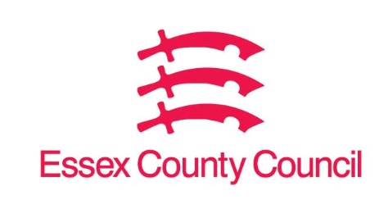

**Freedom of Information Act Request**

Reference: ECC17546506 11 24  
Response: 21 November 2024

I can confirm that Essex County Council does hold some of this information, and where we are able to release this, our response is listed below.

**If you cannot supply using current databases, then I understand but suggest that for future periods such categorisation is added to your databases in order to aid the identification of trends and areas of concern.**

1. **Can you tell me how ECC categorises complaints received, in order to identify trends in particular sectors?**
2. **Please can you advise the total number of complaints received, breaking them down by whatever categories are available, and advise how many complaints were upheld. Can you supply as detailed an answer as possible for the last 5 years so trends and areas of concern can be easily identified?**
3. **Please can you also supply copies of the annual-self assessment against the LG&SCO’s complaint handling code together with copies of the regular and annual reports to the member responsible for complaints that 9.7 of that code sets as a bare minimum.**

**I can see the complaints report for adult and children’s social care for 2023 to 2024 on the website but no other categories.**

1. All complaints are split into Topics by service area as detailed on the attached sheet.
2. We only hold records for the past 3 years. Numbers of received complaints and upheld can be seen on the attached sheet and are split in categories.
3. The code this refers to has not been introduced yet. This will not be implemented until April 2026 at the earliest.

**Your Right to Know**

Democracy and Transparency

Essex County Council

Telephone: 033301 38989

Email: [YourRight.ToKnow@essex.gov.uk](mailto:YourRight.ToKnow@essex.gov.uk) | [www.essex.gov.uk](http://www.essex.gov.uk)