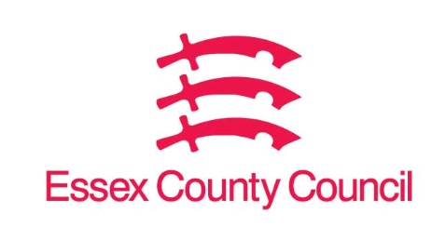

**Freedom of Information Act / Environmental Information Regulations Request**

Reference: ECC17729617 12 24  
Response: 17 December 2024

1. **Sip Trunking**

* Have you implemented sip?
* If yes, when does the contract expire?
* Who is your sip provider?

1. **Team licences**

* Which Microsoft 365 licence do you have e.g. e3, e5 have you voice enable your Teams licences?
* If not, is that something you are considering?

1. **Telephony**

* What is your current telephony system?
* How many users of the telephony system?
* When is the contract up for renewal?

1. **Contact Centre**

* What contact centre solution is the council using?
* How many agents does the contact centre employ?
* How many agents are concurrently working?
* When is the contract for the contact centre ending?

I can confirm that Essex County Council does hold this information, but it is exempt from disclosure under Section 21 of the Act because the information is available elsewhere.

The information you have requested is available at [Request information](https://secureapps.essex.gov.uk/Freedom_of_information/ResultDetails.aspx?ID=39946)

This acts as a refusal notice in respect of this element of your request.

**Your Right to Know**

Democracy and Transparency

Essex County Council

Telephone: 033301 38989

Email: [YourRight.ToKnow@essex.gov.uk](mailto:YourRight.ToKnow@essex.gov.uk) | [www.essex.gov.uk](http://www.essex.gov.uk)