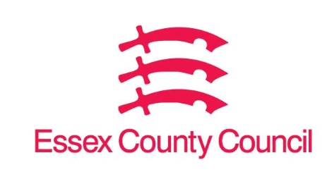

**Freedom of Information Act / Environmental Information Regulations Request**

Reference: ECC19139602 10 25  
Response: 02 October 2025

**Question 1 - How many Public Protection Zones have been created by the council/ local authority in each of the last five years.**

**Question 2 - How many Public Protection Zones are there in total in the council area/ local authority?**

**Question 3 - How many fixed penalty notices have been issued for breaching the rules across the authority in each of the last five years.**

**Question 4 -** **How many people have been prosecuted by the council/ authority in each of the last five years.**

I can confirm that Essex County Council does not hold this information. Your request should be directed to City, District and Borough Councils who may be able to provide you with the information. Please see our webpages which should help you further.

[Request information about the Council | Essex County Council](https://www.essex.gov.uk/running-council/request-information-about-council)

[Contact your local council | Essex County Council](https://www.essex.gov.uk/contact-your-local-council)

**Your Right to Know**

Democracy and Transparency

Essex County Council

Telephone: 033301 38989

Email: [YourRight.ToKnow@essex.gov.uk](mailto:YourRight.ToKnow@essex.gov.uk) | [www.essex.gov.uk](http://www.essex.gov.uk)