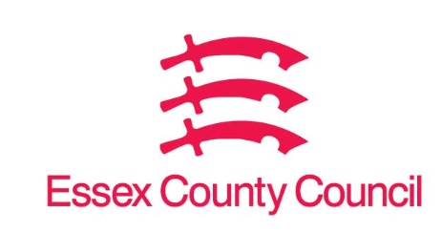

|  |  |  |
| --- | --- | --- |
|  |  |  |

**Freedom of Information Act / Environmental Information Regulations Request**

Reference: ECC17882724 01 25  
Response: 24 January 2025

I can confirm that Essex County Council does not hold this information.

**Could I get the address list of all the vacant properties across the borough of Essex County Council, both public and private dwellings??**

**Maldon council call the list, NDR empty property list.**

I can confirm that Essex County Council does not hold this information. Your request should be directed to City, District and Borough Councils who may be able to provide you with the information. Please see our webpages which should help you further.

[Request information about the Council | Essex County Council](https://www.essex.gov.uk/running-council/request-information-about-council)

[Contact your local council | Essex County Council](https://www.essex.gov.uk/contact-your-local-council)

**Your Right to Know**

Democracy and Transparency

Essex County Council

Telephone: 033301 38989

Email: [YourRight.ToKnow@essex.gov.uk](mailto:YourRight.ToKnow@essex.gov.uk) | [www.essex.gov.uk](http://www.essex.gov.uk)