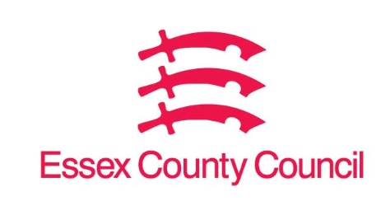

**Freedom of Information Act / Environmental Information Regulations Request**

Reference: ECC19042915 09 25  
Response: 15 September 2025

**Question 1 - I am writing to request the urgent preservation of any CCTV or traffic camera footage that may cover the A12/M25 Junction 28 (Brook Street Roundabout) area.**

**• Date: 12 September 2025**

**• Time: Between 16:50 and 16:57**

**• Location: A12 southbound slip road to the Brook Street Roundabout (M25 Junction 28), Chelmsford → Brentwood direction**

I can confirm that Essex County Council does not hold this information.

As shown online at [Traffic Cameras and Car Parks | Essex County Council (essexhighways.org),](https://www.essexhighways.org/interactive-maps-and-live-travel-information/traffic-cameras-and-car-parks)our traffic monitoring cameras are for traffic monitoring purposes only and are not recorded, we are unable to supply footage to assist with accident claims.

**Your Right to Know**

Democracy and Transparency

Essex County Council

Telephone: 033301 38989

Email: [YourRight.ToKnow@essex.gov.uk](mailto:YourRight.ToKnow@essex.gov.uk) | [www.essex.gov.uk](http://www.essex.gov.uk)