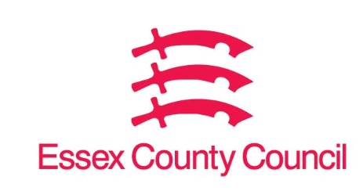

**Freedom of Information Act / Environmental Information Regulations Request**

Reference: ECC18907819 08 25  
Response: 21 August 2025

**Concerning home-to-school transport services involving passengers not entitled to free transport:**

**1. Exempt vehicle usage**

**When was the last time a PSVAR-exempt vehicle was used on such services? Please specify provider, route(s), and date.**

**2. Eliminating exempt vehicles**

**What contractual measures or guidance have you implemented to ensure exempt vehicles are no longer used on these particular trips?**

**3. PSVAR-compliant fleet share**

**Of the vehicles deployed on these specific non-entitled passenger services, how many (number and percentage) are fully PSVAR-compliant?**

**How do you ensure that companies providing home to school services have the requisite number and proportion of fully PSVAR compliant vehicles as required from 1st august 2025 depending on their fleet size?**

**4. Monitoring & enforcement**

**How is compliance monitored? What are the consequences or remediation steps if providers fail to meet no-use or compliance obligations?**

**5. Related documentation**

**Please forward any policy documents, guidance, risk assessments, correspondence with providers, or exemption requests related to PSVAR compliance for this category of school transport.**

I can confirm that Essex County Council does not hold this information, as we do not have any passengers not entitled to free home to school transport.

**Your Right to Know**

Democracy and Transparency

Essex County Council

Telephone: 033301 38989

Email: [YourRight.ToKnow@essex.gov.uk](mailto:YourRight.ToKnow@essex.gov.uk) | [www.essex.gov.uk](http://www.essex.gov.uk)