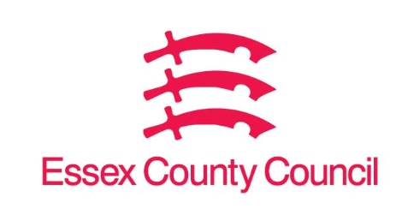

**Freedom of Information Act / Environmental Information Regulations Request**

Reference: ECC18052226 02 25  
Response: 11 March 2025

I can confirm that Essex County Council does not hold this information.

**Question 1****. Please list any current contracts you have with Serco Ltd and/or Serco Group Plc, including ongoing contracts and contracts that end within the financial year 2024-25.**

**This breakdown should cover the purpose and remit of the contract, its slated and actual duration (including start and finish dates) and the contract size (i.e. its price).**

**Question 2. Please also state if there were any recorded instances of misconduct, contract violation, or grievance related to these contracts.**

The Authority does not currently hold any contracts with Serco Ltd and/or Serco Group.

**Your Right to Know**

Democracy and Transparency

Essex County Council

Telephone: 033301 38989

Email: [YourRight.ToKnow@essex.gov.uk](mailto:YourRight.ToKnow@essex.gov.uk) | [www.essex.gov.uk](http://www.essex.gov.uk)