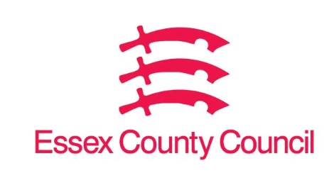

**Freedom of Information Act / Environmental Information Regulations Request**

Reference: ECC17637926 11 24  
Response: 28 November 2024

I can confirm that Essex County Council does hold this information, and where we are able to release this, our response is listed below.

**Question 1****. I am a research associate at private equity international (PEI Group) and responsible for ensuring that the information on our database accurate and up to date. I understand that Essex Pension Fund has a board meeting on 27/11/2024. I was hoping I could get a board packet so I can ensure the data on our website is accurate. To be more specific I’m looking for board meeting minutes that cover items such as pacing plans, any new commitments, and changes in assets under management or investment allocations.**

The agenda, reports and papers from the Investment Steering Committee (ISC) meeting held on the 27/11/2024 can be found on the Council's Committee Management system (CMIS).

This is the link to CMIS: [Essex County Council CMIS](https://cmis.essex.gov.uk/essexcmis5/Committees.aspx).

The ISC meeting took place yesterday (27/11/24) and the minutes have not been written yet, these will be available on CMIS on or before the 13/12/2024.

**Your Right to Know**

Democracy and Transparency

Essex County Council

Telephone: 033301 38989

Email: [YourRight.ToKnow@essex.gov.uk](mailto:YourRight.ToKnow@essex.gov.uk) | [www.essex.gov.uk](http://www.essex.gov.uk)