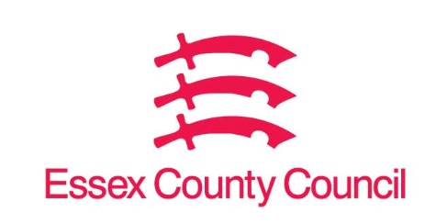

**Freedom of Information Act Request**

Reference: ECC18340825 04 25  
Response: 25 April 2025

1. **How many public toilets are currently open in your council area and how many of these are accessible?**
2. **How many public toilets have been open for each of the years 2020, 2021, 2022, 2023 and 2024 and how many have been accessible?**
3. **How much is currently being spent on providing and maintaining public toilets in your council area and how much has been spent for each of the years 2020, 2021, 2022, 2023 and 2024?**
4. **How many of the public toilets available require the public to pay to access them, how much do they charge, for this year and each of the years 2020, 2021, 2022, 2023 and 2024?**

I can confirm that Essex County Council does not hold this information, ECC is not responsible for public toilets.

Your request should be directed to City, District and Borough Councils who may be able to provide you with the information. Please see our webpages which should help you further.

[Request information about the Council | Essex County Council](https://www.essex.gov.uk/running-council/request-information-about-council)

[Contact your local council | Essex County Council](https://www.essex.gov.uk/contact-your-local-council)

**Your Right to Know**

Democracy and Transparency

Essex County Council

Telephone: 033301 38989

Email: [YourRight.ToKnow@essex.gov.uk](mailto:YourRight.ToKnow@essex.gov.uk) | [www.essex.gov.uk](http://www.essex.gov.uk)