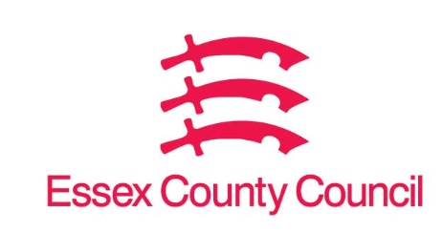

**Freedom of Information Act / Environmental Information Regulations Request**

Reference: ECC18448815 05 25  
Response: 15 May 2025

I can confirm that Essex County Council does hold this information, and where we are able to release this, our response is listed below.

**I request a copy of the quarterly public records from 4q24 for the following information, preferably in excel or pdf format.**

**1. Names and vintage years of all private equity, venture capital, mezzanine, distressed, real estate/reit, debt and infrastructure partnerships in Essex County Council pension fund's portfolio.**

**2. Commitments made to each partnership.**

**3. Contributions drawn down since inception.**

**4. Distributions made to Essex County Council pension fund to date by each individual partnership.**

**5. Net asset value of each partnership.**

**6. Internal rates of return (irrs) for each partnership with and without the use of credit facility. Please note if the irrs are not net.**

**7. Investment multiple (tv/pi) for each individual partnership.**

**8. The dollar amount of “total management fees and costs paid” for each individual partnership.**

**9. Date as of which all the above data was calculated.**

**10. Names of all alternative asset partnerships partially and fully sold by Essex County Council pension fund, including date of sale.**

**11. For each fund, please indicate whether or not the fund uses subscription credit facilities.**

**I also request a copy of any disclosable documents which contain some or all of the following information:**

**12. Names of all hedge fund holdings (including hedge fund of funds) in Essex County Council pension fund's portfolio.**

**13. Month by month market value for each hedge fund holding (including hedge fund of funds) since Essex County Council pension fund's initial investment up to 4q24.**

**14. Month by month contributions to each hedge fund holding (including hedge fund of funds) since Essex County Council pension fund's initial investment up to 4q24.**

**15. Month by month returns (net of fees) earned by Essex County Council pension fund for each hedge fund holding (including hedge fund of funds) since initial investment up to 4q24.**



Please note that in regard to Q11 the Investment Team that manages the private equity mandate has confirmed that there are no restrictions on the underlying partnerships making use of subscription credit facilities. The Fund does not, however, hold information as to which partnerships may make use of this facility.

Also, in regard to Q12 – Q15 the Fund does not invest in hedge funds.

**Your Right to Know**

Democracy and Transparency

Essex County Council

Telephone: 033301 38989

Email: [YourRight.ToKnow@essex.gov.uk](mailto:YourRight.ToKnow@essex.gov.uk) | [www.essex.gov.uk](http://www.essex.gov.uk)