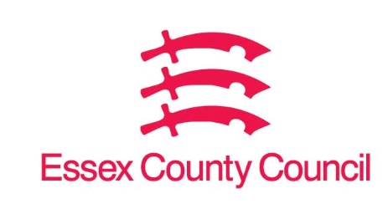

**Freedom of Information Act / Environmental Information Regulations Request**

Reference: ECC17887527 01 25  
Response: 28 January 2025

I can confirm that Essex County Council does hold this information, and where we are able to release this, our response is listed below.

**I am writing to request information under the Freedom of Information Act 2000 regarding your council’s actions relating to non-compliant trading practices, particularly involving stores selling illegal tobacco and vaping products, between 2020 and 2024.**

**Question 1. Specifically, I would like to request the following information:**

**Store closure orders:**

* **the number of stores that have been issued closure orders by your council during this period due to the sale of illegal tobacco and vaping products seizures of vapes:**
* **the total number of vapes seized by your council's trading standards or other relevant teams during this period.**
* **the total estimated monetary value (£) of the seized vapes.**

**I would prefer to receive the requested information in electronic format, and if possible, broken down by year (2020, 2021, 2022, 2023, and 2024).**

I can confirm that Essex County Council does hold this information, but it is exempt from disclosure under Section 21 of the Act because the information is available elsewhere.

The information you have requested is available at  [Request information (essex.gov.uk)](https://secureapps.essex.gov.uk/Freedom_of_information/) by searching “vapes and tobacco”.

This acts as a refusal notice in respect of your request.

**Your Right to Know**

Democracy and Transparency

Essex County Council

Telephone: 033301 38989

Email: [YourRight.ToKnow@essex.gov.uk](mailto:YourRight.ToKnow@essex.gov.uk) | [www.essex.gov.uk](http://www.essex.gov.uk)