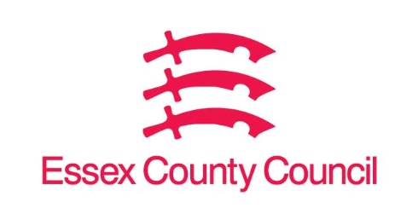

**Freedom of Information Act Request**

Reference: ECC18122711 03 25  
Response: 11 March 2025

1. **Confirmation as to whether this council has at any point in the last 12 months suspended claims for housing benefit from a supported housing provider**
2. **A list of the supported housing providers the council suspended claims for housing benefit from**
3. **A breakdown of the reasons for suspending claims for housing benefit from those supported housing providers**
4. **A timeline of when these suspensions happened**

I can confirm that Essex County Council does not hold this information, we are not responsible for the allocation of housing benefit.

Your request should be directed to City, District and Borough Councils who may be able to provide you with the information. Please see our webpages which should help you further.

[Request information about the Council | Essex County Council](https://www.essex.gov.uk/running-council/request-information-about-council)

[Contact your local council | Essex County Council](https://www.essex.gov.uk/contact-your-local-council)

**Your Right to Know**

Democracy and Transparency

Essex County Council

Telephone: 033301 38989

Email: [YourRight.ToKnow@essex.gov.uk](mailto:YourRight.ToKnow@essex.gov.uk) | [www.essex.gov.uk](http://www.essex.gov.uk)