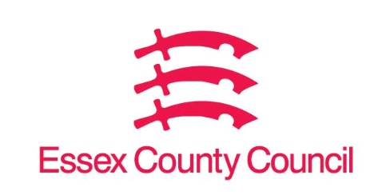

**Freedom of Information Act / Environmental Information Regulations Request**

Reference: ECC18720311 07 25  
Response: 15 July 2025

I can confirm that Essex County Council does hold this information, and where we are able to release this, our response is listed below.

**Please can you provide the following information:**

1. **The number of £200 fines issued by your local authority to individuals or businesses for breaches of the ban on single use vapes that came into force on 1 June 2025.**

0

1. **The total value of these fines issued to date.**

0

**Your Right to Know**

Democracy and Transparency

Essex County Council

Telephone: 033301 38989

Email: [YourRight.ToKnow@essex.gov.uk](mailto:YourRight.ToKnow@essex.gov.uk) | [www.essex.gov.uk](http://www.essex.gov.uk)