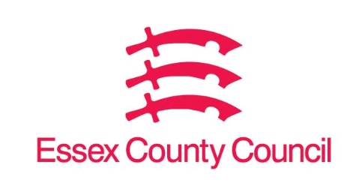

**Freedom of Information Act Request**

Reference: ECC17629325 11 24  
Response: 28 November 2024

I can confirm that Essex County Council does not hold this information.

**Question 1 -** **How long did it take to implement your digital strategy?**

**Response**: Essex County Council does not have currently have a Digital Strategy of its own, so does not hold this information.

**Question 2 - Are you expecting your strategy to realise efficiencies? How are the broken down into:**

**Cashable savings? Non-cashable savings?**

**Question 3 - What specific areas/directorates have you found most efficiencies to date?**

**Question 4 -** **What specifics of digital innovation have been the most successful with regards to efficiencies?**

**Question 5 -** **What have been your main barriers to realising efficiencies?**

Response: Not applicable. See answer to question 1.

**Your Right to Know**

Democracy and Transparency

Essex County Council

Telephone: 033301 38989

Email: [YourRight.ToKnow@essex.gov.uk](mailto:YourRight.ToKnow@essex.gov.uk) | [www.essex.gov.uk](http://www.essex.gov.uk)