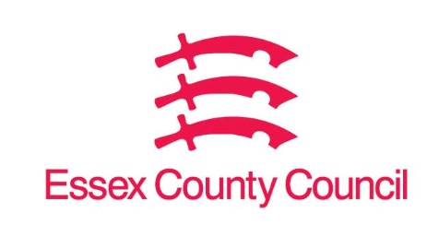

**Freedom of Information Act Request**

Reference: ECC18314122 04 25  
Response: 25 April 2025

I can confirm that Essex County Council does hold this information, and where we are able to release this, our response is listed below.

1. **Please see attached template.**

**I am doing a research project investigating call-off contracts in the public sector. I have identified two potential call-off contracts awarded by Essex County Council, but I can't find details of the framework agreements they were awarded from.**

**I have attached an excel file that contains the information I am looking at. The last two columns ("title of framework used" and "further framework info") is where I am missing information. Please could you provide the name of the specific framework agreements or DPS agreements used here. If there is any further info which you think would help me locate the framework agreements (e.g., a link to the framework's contract finder or fts listing, the framework provider, or a widely used reference number such as CCS's RM codes), please use the final column for this.**

**Please note that I have identified these contracts as possible call-off contracts, so some of them might not be. Some could be, for instance, procured directly (without being called off from a framework agreement), or could be themselves notices of the establishment of a framework agreement. Therefore, I would kindly ask you to specify in these incidences what kind of procurement was used in the "title of framework used" column.**

**I have provided the title, description, the publication date, and procedure type used to award each potential call-off, as well as a URL link to the call-off in question and a unique reference id for each potential call-off. Please let me know if there is anything else you need to complete the request.**

Please see the completed spreadsheet.

**Your Right to Know**

Democracy and Transparency

Essex County Council

Telephone: 033301 38989

Email: [YourRight.ToKnow@essex.gov.uk](mailto:YourRight.ToKnow@essex.gov.uk) | [www.essex.gov.uk](http://www.essex.gov.uk)