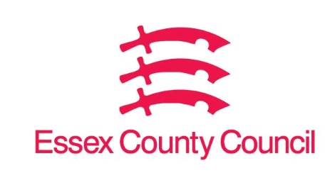

**Freedom of Information Act Request**

Reference: ECC18220028 03 25  
Response: 10 April 2025

I can confirm that Essex County Council does hold some of this information, and where we are able to release this, our response is listed below.

**I am writing to you under the Freedom of Information Act 2000 (‘the Act’) to request information regarding the enforcement of general protections for the welfare of decapod crustaceans during transport and at the time of killing.**

**In relation to each of the questions asked, please take any reference to ‘WATEO’ to mean:**

**• The Welfare of Animals (Transport) (England) Order 2006**

**In relation to each of the questions asked, please take any reference to ‘WATOK’ to include:**

**• The Welfare of Animals at The Time of Killing (England) Regulations 2015**

**Please respond to the following questions. we are happy to receive the information in this form, or any other.**

1. **Which department or agency is responsible for the enforcement of a) WATEO and b) WATOK?**

Q1)

WATEO Trading Standards

WATOK APHA Official Veterinarians:

Official veterinarians are responsible for monitoring and enforcing animal welfare requirements to ensure animals are spared avoidable pain, distress, or suffering during killing and related operations.

1. **What roles within the authority are designated to enforce a) WATEO and b) WATOK, and what formal training, if any, is provided to those roles to ensure the council’s enforcement obligations are fulfilled?**

Q2)

WATEO 7(8) officers trained, authorised and experienced with one other currently undertaking the required training.

WATOK Not held.

1. **Does the authority hold any records on the number of decapod crustaceans transported within or into the authority since 2022? If so, please provide available figures, broken down by year.**

Q3

No.

1. **Does the authority maintain a register or licensing scheme for businesses selling live decapods? If so, how many businesses are currently registered?**

Q4)

No.

1. **Since 2022, how many reports has the authority received that relate to potential offences under article 4 of WATEO? Please provide separate figures for each year.**

Q5)

None relating to decapods

1. **Since 2022, how many reports has the authority received that relate to potential offences under schedule 4 of WATOK? Please provide separate figures for each year.**

Q6)

None held.

1. **Does the authority have any policies relating to the sale of live decapods on council-owned land, including markets.**

Q)7

NO

1. **Has the authority issued any guidance relating to adherence to a) WATEO and b) WATOK for officers responsible for inspections and enforcement or ii) businesses subject to the regulations?**

Q8)

WATEO Regular training and monthly meetings for staff and information and guidance provided to businesses during inspections/visits.

WATOK None held

**Your right to know**

Democracy and transparency

Essex county council

Telephone: 033301 38989

Email: [yourright.toknow@essex.gov.uk](mailto:YourRight.ToKnow@essex.gov.uk) | [www.essex.gov.uk](http://www.essex.gov.uk)