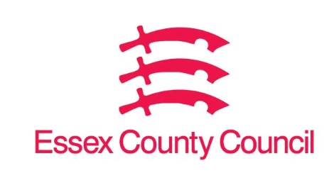

**Freedom of Information Act / Environmental Information Regulations Request**

Reference: ECC17670703 12 24  
Response: 03 December 2024

**School – Chelmsford County School for girls**

**Period covering – school years 2022/23, 2023/24, 2024/25 till 31st October 2024.**

1. **How many children in each period took equal or greater of 10 sessions or more that were approved.**
2. **How many children in each period took equal or greater of 10 sessions or more that were not approved.**

Essex County Council does not hold this information.  Since the introduction of Local Management under the Education Reform Act (1988) individual schools are responsible for pupil absence.   Some or all of the information you require may be held by Chelmsford High School – [Home - Chelmsford County High School for Girls](https://www.cchs.co.uk/)

**Your Right to Know**

Democracy and Transparency

Essex County Council

Telephone: 033301 38989

Email: [YourRight.ToKnow@essex.gov.uk](mailto:YourRight.ToKnow@essex.gov.uk) | [www.essex.gov.uk](http://www.essex.gov.uk)