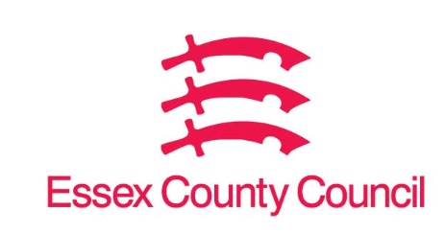

**Freedom of Information Act / Environmental Information Regulations Request**

Reference: ECC18705108 07 25  
Response: 08 July 2025

1. **The number of repair requests submitted by tenants of council owned housing that relate specifically to issues of damp or mould between 1st January 2022 and 1st January 2025. Please provide figures for 2022, 2023 and 2024.**
2. **The average amount of time taken (in days) between an initial repair request being submitted - relating specifically to issues of damp or mould - and investigation by the council (or council sub-contractors) between 1st January 2022 and 1st January 2025. Please provide figures for 2022, 2023 and 2024.**
3. **The average amount of time taken (in days) for the council (or council sub-contractors) to complete a repair for damp or mould between 1st January 2022 and 1st January 2025. Please provide figures for 2022, 2023 and 2024.**
4. **The total number of complaints received by tenants of council owned housing, relating to repairs for damp and mould i.e. because repairs have not been completed or repairs have not been completed to a suitable standard.**

I can confirm that Essex County Council does not hold this information, ECC is not a Tier 2 Housing Authority.

Your request should be directed to City, District and Borough Councils who may be able to provide you with the information. Please see our webpages which should help you further.

[Request information about the Council | Essex County Council](https://www.essex.gov.uk/running-council/request-information-about-council)

[Contact your local council | Essex County Council](https://www.essex.gov.uk/contact-your-local-council)

**Your Right to Know**

Democracy and Transparency

Essex County Council

Telephone: 033301 38989

Email: [YourRight.ToKnow@essex.gov.uk](mailto:YourRight.ToKnow@essex.gov.uk) | [www.essex.gov.uk](http://www.essex.gov.uk)