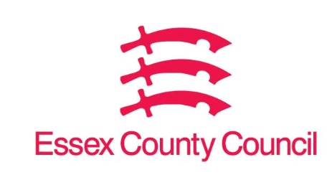

**Freedom of Information Act Request**

Reference: ECC18343225 04 25  
Response: 29 April 2025

I can confirm that Essex County Council does hold this information, and where we are able to release this, our response is listed below.

1. **The name of your Adult Social Care case management system.**
2. **The name of your Children’s Services case management system.**
3. **The name of your education case management system.**
4. **The name of your Housing Management system.**
5. **The name of your Finance or ERP system.**
6. **Please could you also provide the expiration date of your contract with the system supplier for the following system:**

* **Adult social care case management system.**
* **Children’s services case management system.**
* **Education case management system.**
* **Housing management system.**
* **Finance/ERP system.**

1. Mosaic – 22/07/2025
2. Mosaic – 22/07/2025
3. EIMS – 24/11/2025
4. Housing Management - Housing and property management are not an ECC responsibility. It is the responsibility of Borough, City, District and Unitary authorities. Please see attached list of councils in Essex.
5. Oracle Fusion Cloud Applications – 30/04/205 with an option to extend.

**Your Right to Know**

Democracy and Transparency

Essex County Council

Telephone: 033301 38989

Email: [YourRight.ToKnow@essex.gov.uk](mailto:YourRight.ToKnow@essex.gov.uk) | [www.essex.gov.uk](http://www.essex.gov.uk)