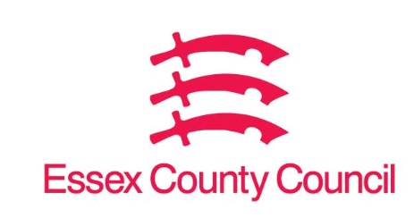

**Freedom of Information Act / Environmental Information Regulations Request**

Reference: ECC18510329 05 25  
Response: 06 June 2025

I can confirm that Essex County Council does hold this information, and where we are able to release this, our response is listed below.

**The information that we require, under the Freedom of Information Act, is as follows:**

1. **Do you use a citizen engagement platform?**

Yes

1. **If so, what tools do you use?**

Consultation Platform- Delib Limited and Community Consultation & Mapping Platform- Granicus Firmstep

1. **How much do you spend annually on a citizen engagement tool?**

Consultation Platform- £6,665.00 Community Consultation & Mapping Platform £21,125.00 both contacts totalled annually at £27,790.00

**4) Which month & year does your contract with your supplier end?**

Consultation Platform- 25/10/2025 and Community Consultation & Mapping Platform 07/01/2026

**Your Right to Know**

Democracy and Transparency

Essex County Council

Telephone: 033301 38989

Email: [YourRight.ToKnow@essex.gov.uk](mailto:YourRight.ToKnow@essex.gov.uk) | [www.essex.gov.uk](http://www.essex.gov.uk)