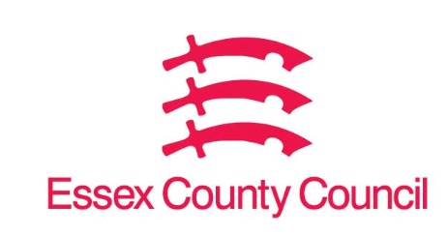

**Freedom of Information Act / Environmental Information Regulations Request**

Reference: ECC17577413 11 24  
Response: 21 November 2024

1. **The amount spent by the council and the local Trading Standards Authority on crime reduction in the form of shoplifting across the independent store sector during 2021, 2022, 2023 and 2024 so far. (the spending by the council and trading standards to be provided separately)**
2. **The amount spent by the council and the local Trading Standards Authority on crime reduction in the form of shoplifting across the symbol store sector during 2021, 2022, 2023 and 2024 so far. (the spending by the council and trading standards to be provided separately)**

I can confirm that Essex County Council does not hold this information. Your request should be directed to City, District and Borough Councils who may be able to provide you with the information. Please see our webpages which should help you further.

[Request information about the Council | Essex County Council](https://www.essex.gov.uk/running-council/request-information-about-council)

[Contact your local council | Essex County Council](https://www.essex.gov.uk/contact-your-local-council)

Alternatively, Essex Police may help you with your enquiry [Home | Essex Police](https://www.essex.police.uk/)

**Your Right to Know**

Democracy and Transparency

Essex County Council

Telephone: 033301 38989

Email: [YourRight.ToKnow@essex.gov.uk](mailto:YourRight.ToKnow@essex.gov.uk) | [www.essex.gov.uk](http://www.essex.gov.uk)