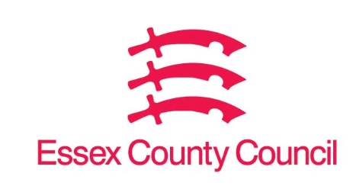

**Freedom of Information Act / Environmental Information Regulations Request**

Reference: ECC18714310 07 25  
Response: 14 July 2025

I can confirm that Essex County Council does not hold this information.

**1 - The number of applications made for HMOs for the years 2018 - 2025 and the number of HMOs registered in your local authority area for the years 2018 - 2025 (number as of 1st January of each year).**

**2 - The number of sanctions issued by your local authority for the years 2018 - 2025 for unlicensed HMOs, broken down by sanction type (banning order, fine, repayment order etc)**

**3 - The number of complaints made about HMOs in your area for the years 2018 - 2025 and the number of these complaints which resulted in enforcement action being taken.**

**4 - The number of HMO licenses revoked for the years 2018 - 2025.**

I can confirm that Essex County Council does not hold this information. Your request should be directed to City, District and Borough Councils who may be able to provide you with the information. Please see our webpages which should help you further.

[Request information about the Council | Essex County Council](https://www.essex.gov.uk/running-council/request-information-about-council)

[Contact your local council | Essex County Council](https://www.essex.gov.uk/contact-your-local-council)

**Your Right to Know**

Democracy and Transparency

Essex County Council

Telephone: 033301 38989

Email: [YourRight.ToKnow@essex.gov.uk](mailto:YourRight.ToKnow@essex.gov.uk) | [www.essex.gov.uk](http://www.essex.gov.uk)