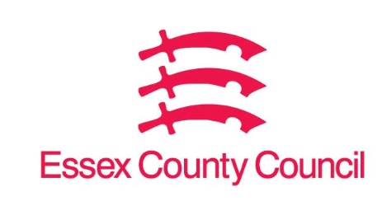

**Freedom of Information Act / Environmental Information Regulations Request**

Reference: ECC18986804 09 25  
Response: 15 September 2025

I can confirm that Essex County Council does hold this information, and where we are able to release this, our response is listed below.

1. **The total number of pothole compensation claims received for each of the financial years 2021/22, 2022/23, 2023/24, 2024/25 and 2025/26 (to date).**
2. **The total number of pothole compensation claims resolved for each of the financial years 2021/22, 2022/23, 2023/24, 2024/25 and 2025/26 (to date). And of those resolved, please specify how many were successful (ie. Resulted in a payment), and how many were rejected.**
3. **For the same time period, please provide:**

* **The total amount paid out in compensation each financial year**
* **The highest single payout made each financial year**
* **The total legal costs incurred by the council each financial year in relation to pothole compensation claims, including costs associated with in-house legal teams, external solicitors, barristers, or private legal firms.**

|  |  |  |  |  |  |  |
| --- | --- | --- | --- | --- | --- | --- |
|  | No of Pothole Claims received | No of Admitted claims | No of Denied claims | Total Damages Payments | Highest Single Payment | Total legal costs |
| 21/22 | 1353 | 55 | 1159 | £123,085.53 | £21,888.68 | £172,949.43 |
| 22/23 | 1762 | 113 | 1439 | £166,188.14 | £32,134 | £179,272.86 |
| 23/24 | 2684 | 145 | 2271 | £200,731.79 | £75,000 | £194,003.19 |
| 24/25 | 1686 | 49 | 1496 | £217,235.17 | £27,500 | £192,025.42 |
| 25/26 (to 09.09.25) | 286 | 1 | 232 | £77,461.67 | £11,000 | £67,383.11 |

Please note the following:

* Number of claims received, number of admitted claims and number of denied claims are based on claims notified to us between 1st April 2021 and 9th September 2025.  This is for all claims relating to pothole damage so includes both vehicle damage and personal injury.
* The number of admitted claims and denied claims will not add up to the total number of claims, as there will be some claims still awaiting a decision and also some claims where we have never received enough information to make a decision.
* The payment information is based on payments made between 1st April 2021 and 9th September 2025 irrespective of incident date.
* Total legal costs does not include in-house legal team, but does include third party costs, counsel’s fees and court fees.

**Your Right to Know**

Democracy and Transparency

Essex County Council

Telephone: 033301 38989

Email: [YourRight.ToKnow@essex.gov.uk](mailto:YourRight.ToKnow@essex.gov.uk) | [www.essex.gov.uk](http://www.essex.gov.uk)