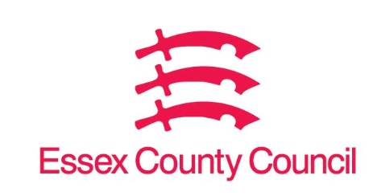

**Freedom of Information Act / Environmental Information Regulations Request**

Reference: ECC18682103 07 25  
Response: 09 July 2025

I can confirm that Essex County Council does hold this information, and where we are able to release this, our response is listed below.

**I'd like to hear about the council's Learning Management System.**

1. **Who supplies the council with an LMS**

Cornerstone OnDemand Limited

1. **What was the start date of the contract**

1 July 2023

1. **What is the end date of the contract**

30 June 2026

1. **How many extensions are available on the contract**

12 months from 1 July 2025 to 30 June 2026

1. **What is the annual cost of the contract**

£413,280

1. **What areas of the council are supported by the LMS**

All Essex County Council employees have access to the LMS

1. **Who is responsible for the LMS**

Alison Woods, Director People & Organisation Development

**Your Right to Know**

Democracy and Transparency

Essex County Council

Telephone: 033301 38989

Email: [YourRight.ToKnow@essex.gov.uk](mailto:YourRight.ToKnow@essex.gov.uk) | [www.essex.gov.uk](http://www.essex.gov.uk)