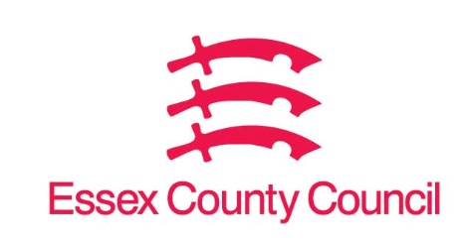

**Freedom of Information Act Request**

Reference: ECC18388602 05 25  
Response: 07 May 2025

I can confirm that Essex County Council does hold this information, and where we are able to release this, our response is listed below.

**Clarification received 01/05 - Essex wide for six months please**

1. **I am trying to establish which claims in Essex were rejected over the last 6 to 12 months and the reasons**

I can confirm that Essex County Council does hold this information, but it is exempt from disclosure under Section 21 of the Act because the information is available elsewhere.

Information on the number of claims received and the number admitted/denied can be found here: [Claims Data | Essex Open Data](https://data.essex.gov.uk/dataset/epzlz/claims-data)

The majority of claims are denied as it cannot be proven that ECC has failed to comply with its statutory duties, further information is available at [Make a claim | Essex County Council (essexhighways.org)](https://www.essexhighways.org/make-a-claim)

This acts as a refusal notice in respect of your request.

**Your Right to Know**

Democracy and Transparency

Essex County Council

Telephone: 033301 38989

Email: [YourRight.ToKnow@essex.gov.uk](mailto:YourRight.ToKnow@essex.gov.uk) | [www.essex.gov.uk](http://www.essex.gov.uk)