Freedom of Information Act / Environmental Information Regulations Request
Reference: ECC21450221 10 26
Response: 26 October 2026

I can confirm that Essex County Council does hold this information, and where we are able to release this, our response is listed below.

I am seeking clarification regarding the speed limit and associated signage on the B183, near the junction with Takeley Park, Takeley, Uttlesford.
I received a speeding notice alleging that I was travelling at 40 mph in a 30 mph limit at this location on 25 August 2026 at approximately 12:15 pm.

I am concerned that I did not see a 30 mph speed-limit sign when entering the relevant stretch of road.
Could you please confirm:
- The applicable speed limit at this precise location on 25 August 2026.
- The relevant Speed Limit Order or Traffic Regulation Order.
- The location and direction of travel associated with the 30 mph signs serving this stretch of road.
- Whether records, inspection reports or photographs are available to confirm the signage in place at the time.

Please see the attached speed order and photos showing the location of the speed terminal signs when heading northerly.

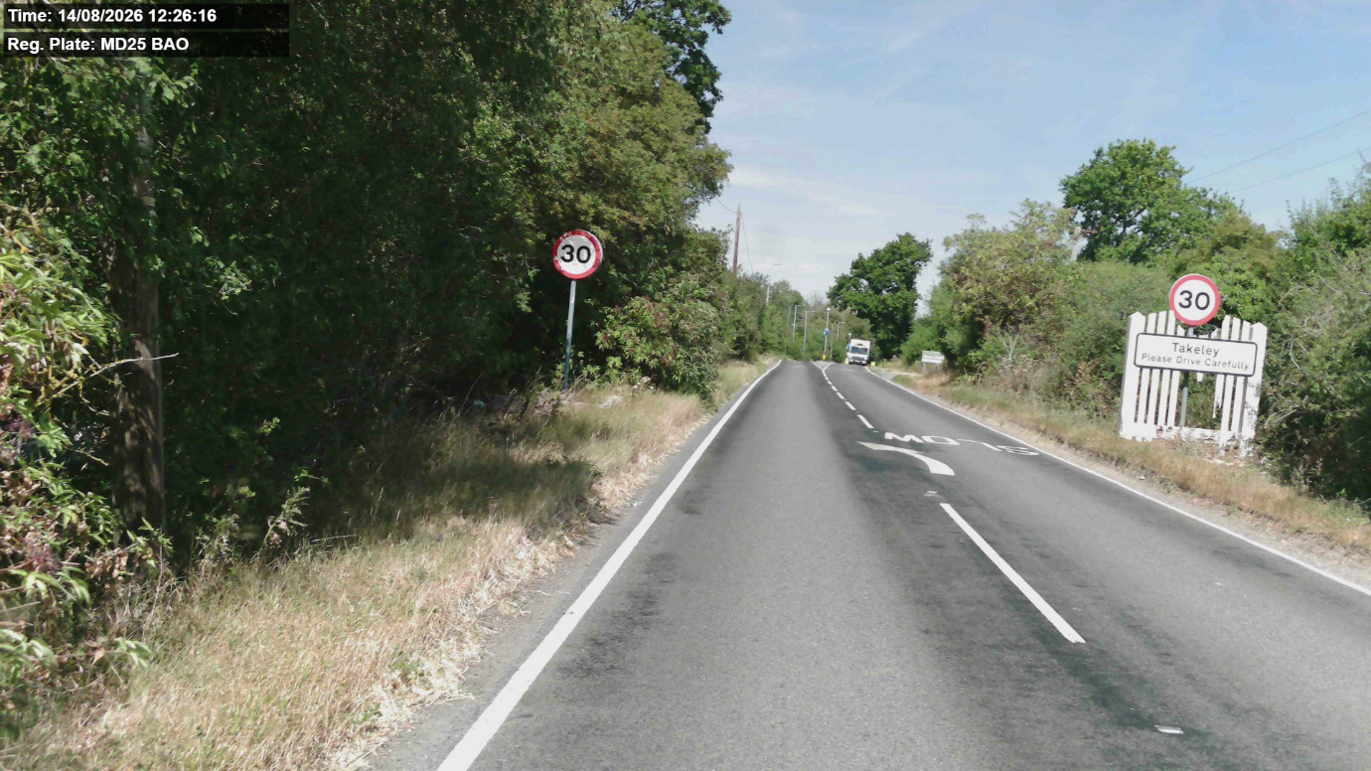
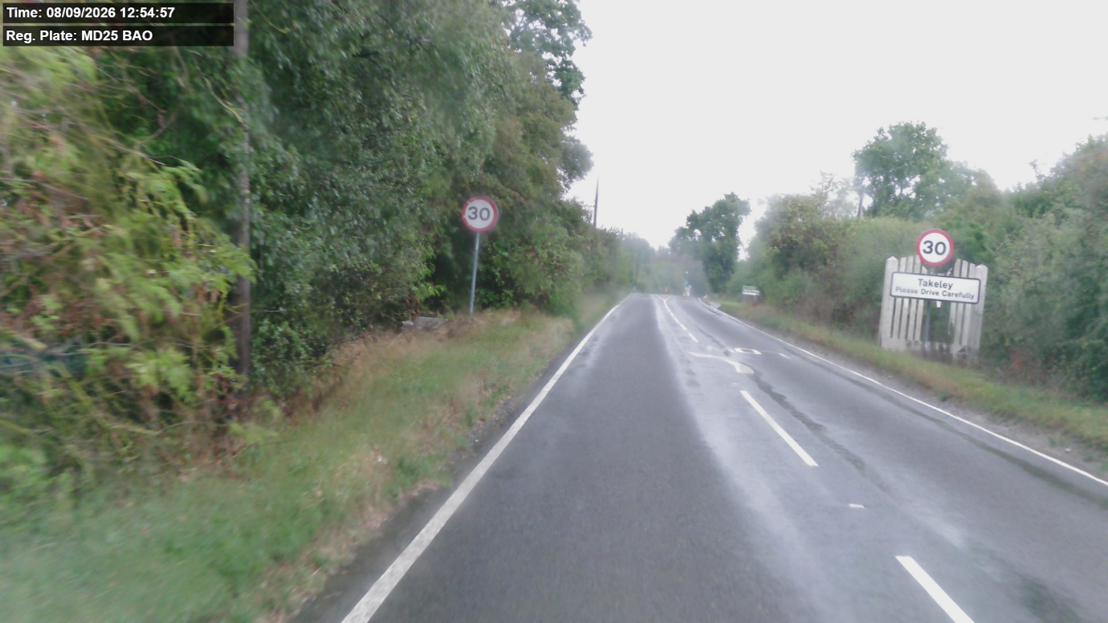

The signs also appear on Google StreetView.

Your Right to Know
Democracy and Transparency
Essex County Council
Telephone: 033301 38989
Email: YourRight.ToKnow@essex.gov.uk | www.essex.gov.uk

