Freedom of Information Act / Environmental Information Regulations Request
Reference: ECC20441301 06 26
Response: 02 June 2026

I can confirm that Essex County Council does hold this information, and where we are able to release this, our response is listed below.

- This may seem a while from the incident back in December 2025 and I am not asking for anything other than an admission that the island at the junction of York Road and Kings Parade, Holland on Sea, Essex was unlit around the dates of 16th to 18th December 2025.

The keep left bollards on the traffic island have been unlit reflective (TMP) signs since at least October 2014, as evident on Google Streetview.

Please the attached site history report that shows that one reflective (TMP) bollard was made safe, by the placement of a large keep left sign on 12/12/2025 and the other reflective (TMP) bollard was made safe by the placement of a large keep left sign on 16/12/2025.

Our current Highway Maintenance Policy and General Principles and our Maintenance & Inspections Strategies are publicly available online www.essexhighways.org/roads-strategies#maintenance.

Details of how inspectors risk assess and prioritise highway issues can also be found on our public web site at www.essexhighways.org/how-we-prioritise-highway-issues.

A speed limit of 30 mph (48 km/h), or 20mph (32km/h) in Wales, generally applies to all roads with street lights (excluding motorways) unless signs show otherwise. Please see Highway Code Rule 124.

Please see the below job photos relating to the jobs shown on the report.

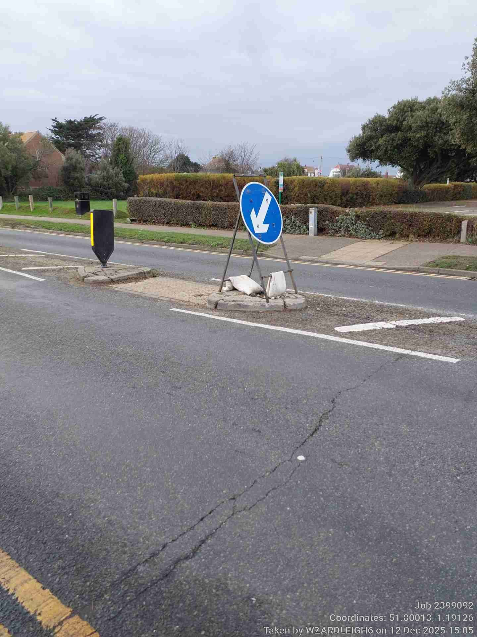
Figure 1 12 Dec 2025
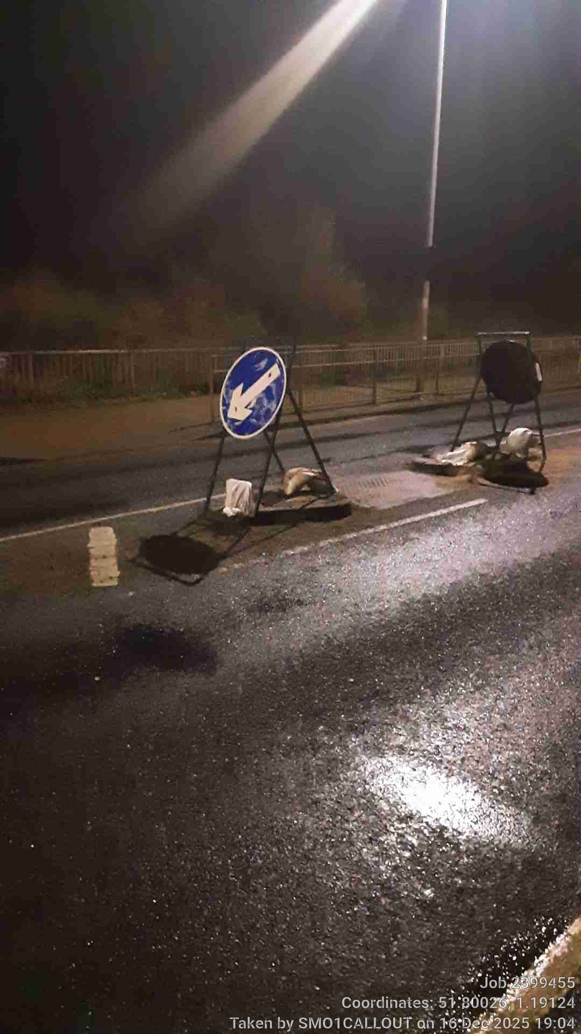
Figure 2 16 Dec 2025

Your Right to Know
Democracy and Transparency
Essex County Council
Telephone: 033301 38989
Email: YourRight.ToKnow@essex.gov.uk | www.essex.gov.uk

