Freedom of Information Act / Environmental Information Regulations Request
Reference: ECC19526415 12 25
Response: 17 December 2025

I can confirm that Essex County Council does hold this information, and where we are able to release this, our response is listed below.

- Full evidence of the consultation process, including:

- Dates notices were issued
- The method of communication
- Proof of who was notified

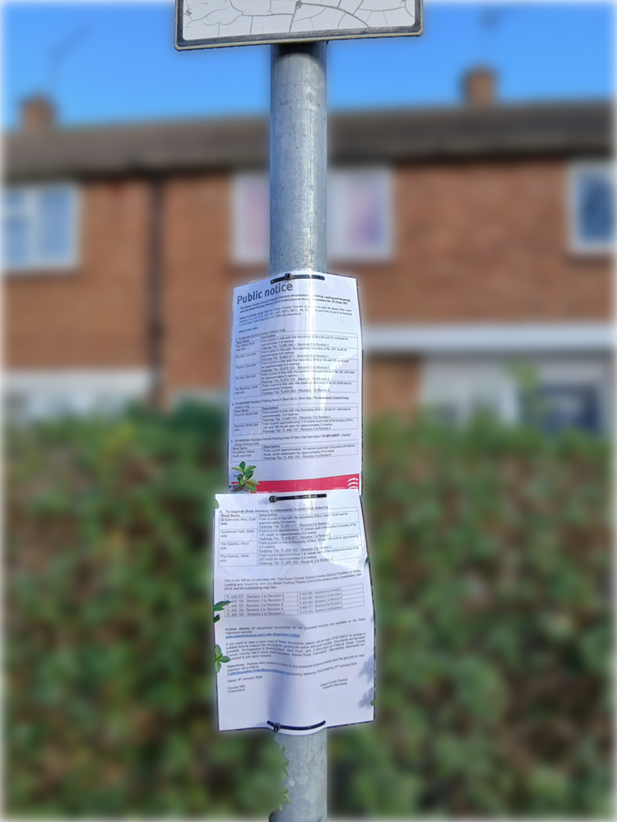
The consultation period for TRAF8488 that included To Revoke: Disabled Badge Holders Only in The Hoo, was advertised from 09 January 2025 until the 31 January 2025 as per the attached notice.

The intention notice was advertised in Epping Forest and Harlow Guardian on the 09 January 2025 (an online version remains on Public Notice Portal).

A standard notification containing all consultation documents was sent to the three relevant county councillors, the parishes and a group of standard consultees and local buses companies (approximately 47 consultees), this also included consulting with NEPP.

Further to that notices were placed on street furniture (as shown).

Resident letters were sent to 555 addresses, 53 of which were in The Hoo.

Specifically in relation to the bay outside The Hoo letters were sent to nearby properties as shown in the AddressBase map below.

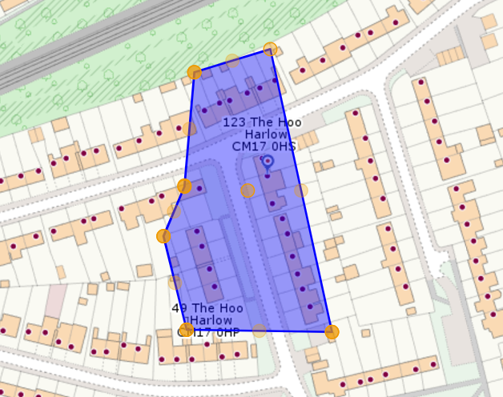

The total distribution was as the table below.

Street | Addresses
Barn Mead | 31
Broadfield | 20
Dunstalls | 6
Fishers Hatch | 2
Mill Field | 22
Priory Avenue | 2
Rivermill | 93
Rundells | 37
St Edmunds Way | 14
St Michaels Close | 23
Sycamore Field | 79
The Dashes | 97
The Hoo | 53
The Hornbeams | 5
The Readings | 22
Wharley Hook | 49

A copy of the resident’s / occupiers letter sent specifically to residents / occupiers of The Hoo has been attached.
You will notice that some information has been withheld (redacted) this is due to an exception in the Environmental Information Regulations.

The exception applicable to the information is:

EIR Regulation 12(3) & Regulation 13 - Personal data of third parties is exempt if disclosure would breach the principles of the Data Protection Act 2018. We believe that providing you with the information would breach the following Data Protection principles:

- Data shall be fairly, lawfully and transparently processed
- Data shall be collected for specified, explicit and legitimate purposes and not further processed in a manner that is incompatible with those purposes
We are applying this exemption because

- we do not have the consent of the person who is the subject of the information to disclose it to you,
- disclosure does not meet any of the Article 6 or 9 conditions that would make it “necessary”, and
- disclosure of the information to you would not be connected to the purpose for which we have collected and are holding the information.
We further believe that the release of the requested information would cause unwarranted interference to the rights and freedoms and legitimate interests of the data subject(s). Such a disclosure would in our view constitute a breach of Article 8 in the Human Rights Act (the right to privacy and family life).

The documents were also publicly available on our website https://www.essexhighways.org/traffic-regulation-orders from 09 January 2025 until the 31 January 2025.

Your Right to Know
Democracy and Transparency
Essex County Council
Telephone: 033301 38989
Email: YourRight.ToKnow@essex.gov.uk | www.essex.gov.uk

