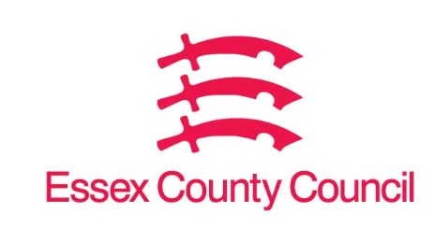

Freedom of Information Act / Environmental Information Regulations Request
Reference: ECC19529215 12 25
Response: 16 December 2025

I can confirm that Essex County Council does not hold this information.
Question 1 - I would like to know is if West Lodge was in the 1961 Census.

The census is carried out by the national government. The personal data that the government collects as part of the census is not held by local authorities. The data is closed to public access for 100 years, so that we would expect data from the 1961 census to be released by the National Archives in 2062.

Your Right to Know
Democracy and Transparency
Essex County Council
Telephone: 033301 38989
Email: YourRight.ToKnow@essex.gov.uk | www.essex.gov.uk

