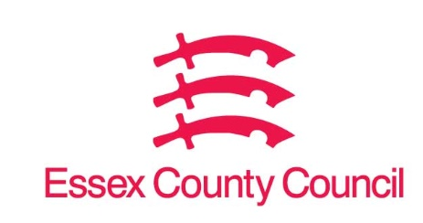

Freedom of Information Act / Environmental Information Regulations Request
Reference: ECC19286029 10 25
Response: 04 November 2025

I can confirm that Essex County Council does not hold this information.
Question 1 - I would like to ask for the number of homes which were sold under RTB rules between the beginning of the scheme in 1980 and March 31, 2025, which have since been rebought by the council (on any date to the date this request is received).
Crucially, I would ask for the following information on each home rebought under the scheme.
- Address (as far as it can be shared)
- Right to buy sale price
- Sale date
- Repurchase price
- Repurchase date

Please let me know if there are any questions about my request. If your council has not repurchased any RTB properties, please indicate so to me.

I can confirm that Essex County Council does not hold this information. Your request should be directed to City, District and Borough Councils who may be able to provide you with the information. Please see our webpage which should help you further, there are contact details of all the councils in Essex as a link on this page.

Request information about the Council | Essex County Council

Your Right to Know
Democracy and Transparency
Essex County Council
Telephone: 033301 38989
Email: YourRight.ToKnow@essex.gov.uk | www.essex.gov.uk

