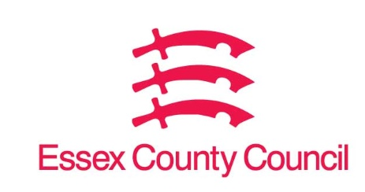

Freedom of Information Act / Environmental Information Regulations Request
Reference: ECC19295930 10 25
Response: 04 November 2025

I can confirm that Essex County Council does not hold this information.
please provide the following details for the last five financial years (or the most recent available period):
- The total quantity by retailer and value of charges or fines levied by your council on retailers for the removal, storage, and disposal of abandoned shopping trolleys, under the powers granted by the Clean Neighbourhoods and Environment Act 2005 and/or schedule 4 of the Environmental Protection Act 1990.
- A breakdown of these charges by retailer, including the number of trolleys recovered and the total amount charged per retailer.
- Any policy documents or fee schedules used to determine the charges applied to retailers for abandoned trolleys.
- Whether your council operates a voluntary trolley collection scheme with retailers, and if so, which retailers are participating.

I can confirm that Essex County Council does not hold this information. Your request should be directed to City, District and Borough Councils who may be able to provide you with the information. Please see our webpage which should help you further, there are contact details of all the councils in Essex as a link on this page.

Request information about the Council | Essex County Council

Your Right to Know
Democracy and Transparency
Essex County Council
Telephone: 033301 38989
Email: YourRight.ToKnow@essex.gov.uk | www.essex.gov.uk

