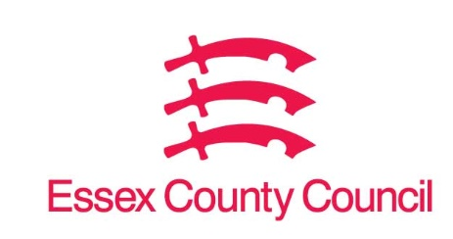

Freedom of Information Act / Environmental Information Regulations Request
Reference: ECC19295330 10 25
Response: 04 November 2025

I can confirm that Essex County Council does hold this information, and where we are able to release this, our response is listed below.
Please could you provide the following information covering the period from 01 July 2025 to the present day, with a month-by-month breakdown of figures for July, August, September, and October 2025:

- The number of £200 fines issued by your local authority to individuals or businesses for breaches of the ban on single-use vapes that came into force on 01 June 2025.
- The total value of these fines issued to date within this timeframe.

If your authority has not issued any such fines during this period, I would be grateful if you could confirm this is the case.

Q1 0

Q2 £0

Essex County Council Trading Standards has not currently implemented fixed penalty notices for dealing with single use vape non-compliance.

Your Right to Know
Democracy and Transparency
Essex County Council
Telephone: 033301 38989
Email: YourRight.ToKnow@essex.gov.uk | www.essex.gov.uk

