Freedom of Information Act / Environmental Information Regulations Request
Reference: ECC18504628 05 25
Response: 06 June 2025

I can confirm that Essex County Council does hold some of this information, and where we are able to release this, our response is listed below.

Question 1 - I want all documents relating to the closure, that's TTRO, risk assessments for diversion, who was consulted and compensation contact. These documents should be online.

Please see the attached documents.

In accordance with the Safety at street works and road works guidance, it is the responsibility of the company carrying out works to risk assess the diversion route. However, as there are no alternative A roads within the Tendring area, it is not possible to divert traffic to the nearest A road, the only alternative is a B road as the next class of road.

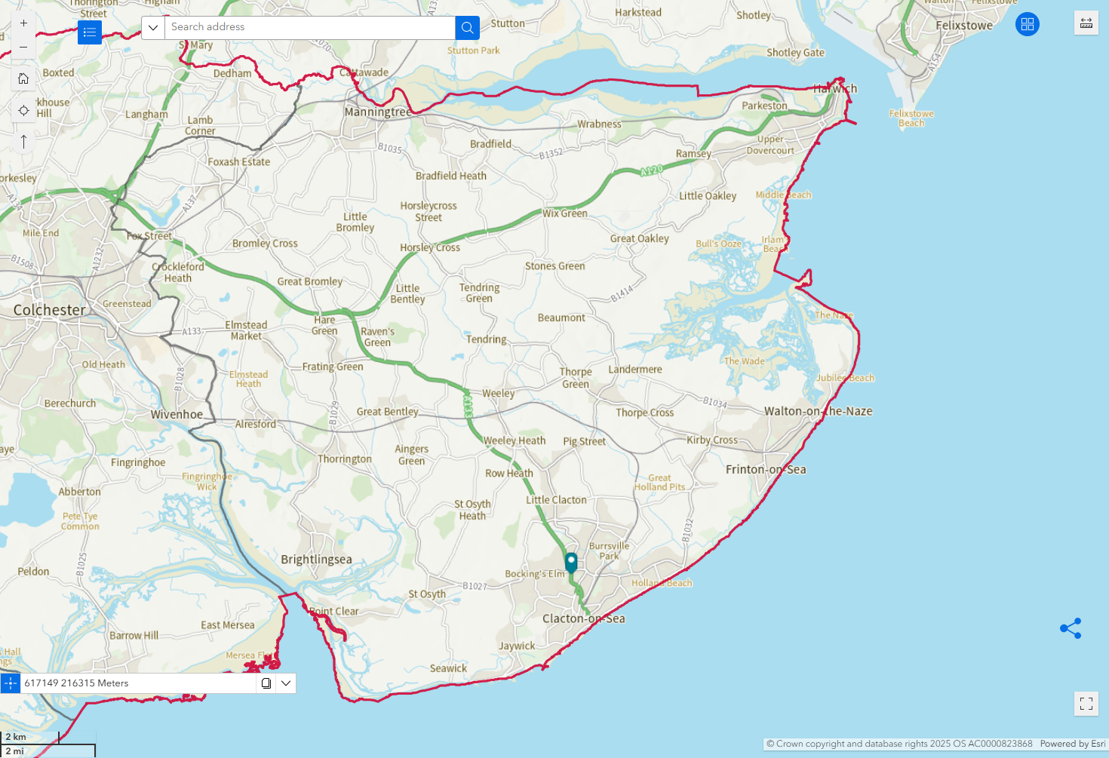
Figure 1- Map showing the A roads (in green) within the Tendring area and the location of the works as a blue pointer
The local county councillor and district council where informed of the intention notice. Notice of road closure and diversion route was also published on one.network, and also in Public Notices section of the Clacton and Frinton Gazette, as well as on their Public Notices Portal on 27/03/25.

Essex County Council does not hold details of who you may wish to claim compensation from and would advise you to take independent legal advice on the matter.

You will notice that some information has been withheld (redacted) this is due to an exception in the Environmental Information Regulations.

The exception applicable to the information is:

EIR Regulation 12(3) & Regulation 13 - Personal data of third parties is exempt if disclosure would breach the principles of the Data Protection Act 2018. We believe that providing you with the information would breach the following Data Protection principles:

- Data shall be fairly, lawfully and transparently processed
- Data shall be collected for specified, explicit and legitimate purposes and not further processed in a manner that is incompatible with those purposes
We are applying this exemption because

- we do not have the consent of the person who is the subject of the information to disclose it to you,
- disclosure does not meet any of the Article 6 or 9 conditions that would make it “necessary”, and
- disclosure of the information to you would not be connected to the purpose for which we have collected and are holding the information.
We further believe that the release of the requested information would cause unwarranted interference to the rights and freedoms and legitimate interests of the data subject(s). Such a disclosure would in our view constitute a breach of Article 8 in the Human Rights Act (the right to privacy and family life).

Your Right to Know
Democracy and Transparency
Essex County Council
Telephone: 033301 38989
Email: YourRight.ToKnow@essex.gov.uk | www.essex.gov.uk

https://www.gov.uk/government/publications/safety-at-street-works-and-road-works
https://one.network/uk/essex
https://publicnoticeportal.uk/notice/traffic-and-roads/67e6c655bdf307d3b7305243

