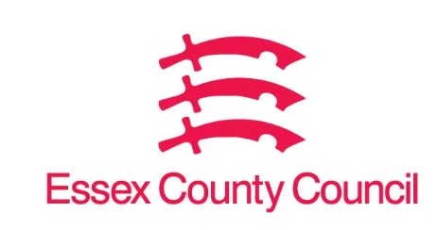

Freedom of Information Act Request
Reference: ECC18215027 03 25
Response: 01 April 2025

I can confirm that Essex County Council does hold this information, and where we are able to release this, our response is listed below.
Question 1. I am writing to you under the Freedom of Information Act 2000 to request information about which financial system/financial management software system your council is currently using.

The Council’s Enterprise Resource Planning (ERP) system, that includes financial management, is an Oracle based system.

Your Right to Know
Democracy and Transparency
Essex County Council
Telephone: 033301 38989
Email: YourRight.ToKnow@essex.gov.uk | www.essex.gov.uk

