Freedom of Information Act / Environmental Information Regulations Request
Reference: ECC17008012 07 24
Response: 23 July 2024

I can confirm that Essex County Council does hold some of this information, and where we are able to release this, our response is listed below.

Question 1 - Outcome of the Scheme Request Forms for LHP for Well Lane and Smallgains Lane for speed reduction to 40mph AND LHP for 20mph zone for various roads (including Well Lane) in Stock village; and all data tracking information obtained for these applications

LCHE232023 – Well Lane/Smallgains Lane, Stock – 40mph/Quite Lane

In order to assess the LHP Scheme Request for a 40mph/Quiet Lane we carried out two automatic traffic counts on Well Lane/Smallgains Lane, Stock to collect traffic speed/volume data.

We have attached the full traffic speed and volume data and provided a summary below -

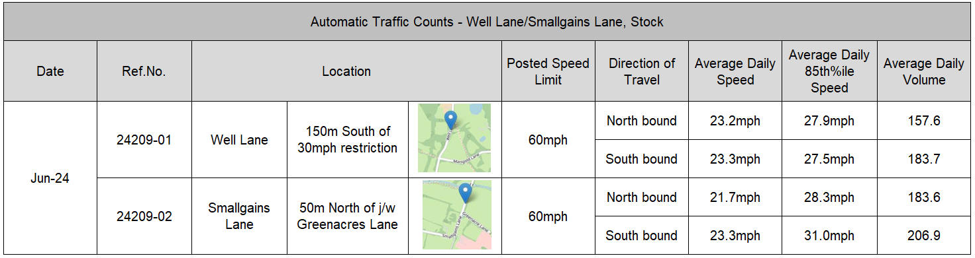

Mean average speed and 85th%ile (the speed at or below which 85% of vehicles are travelling) are the most commonly used measures of traffic speed. Department for Transport guidance is that Traffic Authorities should continue to routinely collect and assess both, but that mean average speeds should be used as the basis for determining local speed limits. Based upon the recorded mean average speeds there would be deemed to be good compliance with the posted speed limit on Well Lane/Smallgains Lane, Stock.

In assessing the request for a 40mph speed limit the existing speeds of 21.7mph to 23.3mph are already below 40mph.

Whilst considering the request for Quiet Lane status, the two roads meet the key criteria -

- A Quiet Lane cannot be a Priority Route 1 or 2 Road and Well Lane/Smallgains Lane are both Local Roads.
- Any Quiet Lane should carry less than 1000 vehicles per day.
- To consider a road for Quiet lane status the 85th percentile speed must be less than 35mph, and on Well Lane/Smallgains Lane they are between 24.5mph and 31.0mph.

As the request for Quiet Lane status meets the key criteria it has now been sent to the Design Team to undertake an LHP Scheme Validation. This is where the Design Team look at the issues raised as well as any suggested solution and put forward feasible engineering solutions to the issues raised. We await the findings from the LHP Scheme Validation process.

LCHE232022 - Stock 20mph Zones

In terms of assessing a road for a 20mph speed zone we would need speed/volume data from an automatic traffic count for each road to be considered. For a 20mph zone the key criteria is as follows –

- Mean speed is always used to assess eligibility.
- Not permitted on Priority 1 Routes.
- Not permitted on Priority 2 Routes.
- Local Roads (estate Roads) can be considered if there is proven strong local support submitted with request.
- No requirement for mean speeds to be 24mph or below, however the speed limit should be self-enforcing with traffic calming within 50m of any given point.
- If mean speeds under 20mph then zone not required.

As yet no traffic surveys have been carried out as part of the request for a 20mph zone. The Design Team have been asked through the LHP Scheme Validation process if it is possible to undertake a Feasibility Study into the requested Stock 20mph zone, which would include any required traffic surveys. The findings of any Feasibility Study would show what could be taken forward as a potential scheme. We await the findings from the LHP Scheme Validation process.

Your Right to Know
Democracy and Transparency
Essex County Council
Telephone: 033301 38989
Email: YourRight.ToKnow@essex.gov.uk | www.essex.gov.uk

